Bellabeat Case Study
Andrew Sagonowsky
1/5/2026
Need to add
Business Task
Analyze smart device usage data to identify behavior trends in activity, sleep, and daily habits, and apply those insights to improve the marketing strategy for the Bellabeat app.
Executive Summary
- Average daily steps ~7.6k; moderate activity overall
- Zero-step days suggest non-tracking/engagement gaps
- Weekday activity slightly higher than weekend activity
- Steps correlate positively with calories
- Steps vs sleep shows weak relationship → holistic wellness messaging

Stakeholders: Bellabeat marketing and executive team
Intended Outcome: data-driven marketing recommendations
Data
Data Sources
- Fitbit Fitness Tracker Data (Kaggle)
- Daily activity, intensity, sleep, and calories
- 33 unique user IDs, ~1 month of data
Data Limitations
- Small sample size
- Non-Bellabeat users
- Incomplete tracking (zero-step days, missing sleep records)
- Historical Data (2016)
Tools and Environment
- RStudio
- tidyverse (dplyr, ggplot2, lubridate)
- Data imported to RStudio via CSV
Data Preparation and Cleaning
- Importing Data
- Imported daily, hourly, sleep, and weight logs into R using RStudio’s import dataset function
- Verified schema and row counts for each table

- Cleaning Steps
- Converted date columns to date format
- Removed duplicated rows
- Standardized column names where needed
- Identified and retained zero-step days as valid non-tracking behavior reflecting non-wear or syncing gaps
- Merging Data
- Joined daily activity and sleep data on ID and date
- Resulted in 410 daily records with valid sleep data
- Sleep analysis limited to days with recorded sleep

Exploratory Analysis
Metrics Calculated
- Average daily steps
- Average active minutes
- Average calories burned
- Weekday vs weekend activity
- Correlation between steps and sleep duration

Visualizations
Chart 1: Distribution of Daily Steps
- Purpose: understand baseline activity and engagement
- Key Observations: majority of days below 10,000 steps, frequent zero-step days
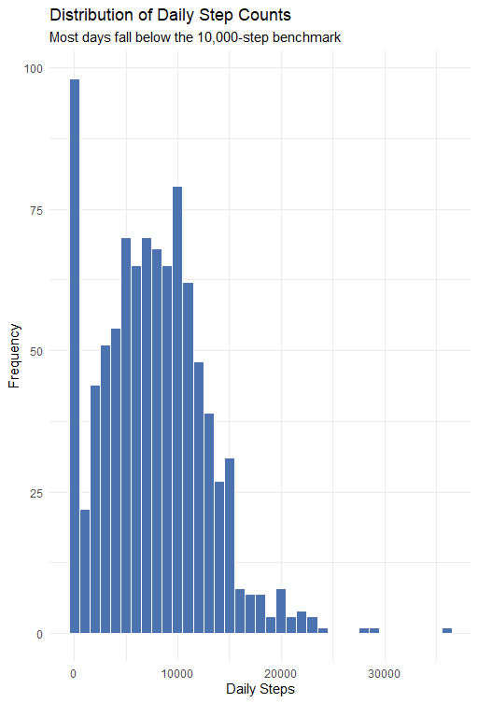
Most daily step counts fall below the 10,000-step benchmark, indicating moderate activity levels across users. A high frequency of zero-step days suggests periods of non-tracking, highlighting opportunities to re-engage users through reminders and habit-forming features.
Chart 2: Weekday vs Weekend Activity
- Purpose: Compare routine-driven behavior
- Key Observation: slightly higher activity on weekdays, overall activity is consistent across day types
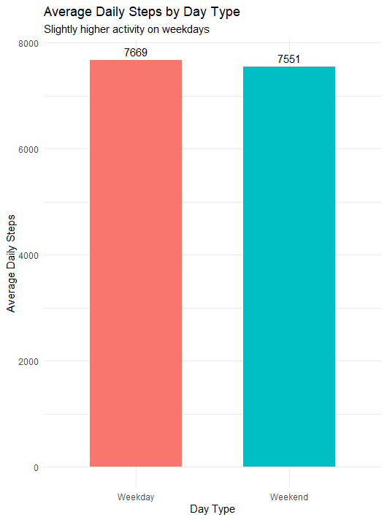
Average daily steps are slightly higher on weekdays than weekends, suggesting that structured routines support more consistent movement. This pattern indicates an opportunity to align weekday messaging with existing habits while positioning weekend content around recovery and balance.
Chart 3: Steps vs Calories Burned
- Purpose: Validate step data as activity proxy
- Key Observation: Positive relationship with some variability
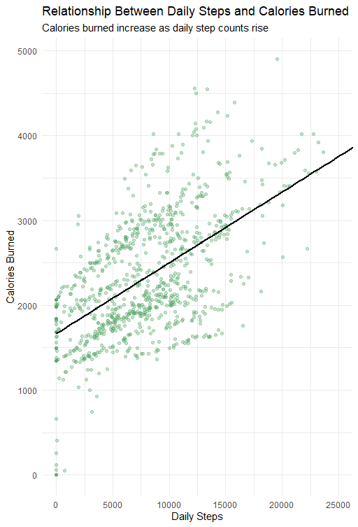
Daily step counts show a clear positive relationship with calories burned, validating the use of step data as a reliable proxy for overall daily activity. Variability at similar step levels suggests that factors beyond steps also influence energy expenditure.
Chart 4: Steps vs Sleep Duration
- Purpose: Assess relationship between activity and rest
- Key Observation: Weak relationship, sleep is influenced by multiple factors
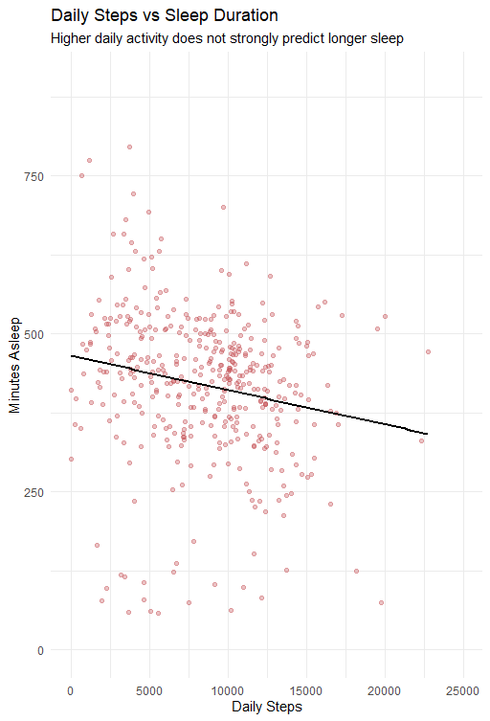
Increased physical activity does not strongly correlate with longer sleep duration. The wide variation in sleep outcomes at similar activity levels highlights the importance of addressing sleep, stress, and recovery as part of a balanced wellness strategy.

Key Insights
- Users show moderate activity levels with room for incremental improvement
- Engagement gaps exist, indicated by zero-step days
- Activity is routine-driven rather than weekend-driven for most users
- Sleep outcomes are not strongly driven by activity alone
Recommendations
- Increase daily engagement through habit-forming reminders
Insight source: Chart 1 (distribution of steps, zero-step days show no engagement)
Recommendation:
Introduce daily reminders and engagement boosts within the Bellabeat app when no activity is recorded, encouraging users to wear their devices and engage with the app consistently.
Rationale:
A high frequency of zero-step days suggests periods of non-tracking rather than complete inactivity. Timely reminders, streak tracking, or different motivational methods could help improve engagement and build daily usage habits.

- Align marketing messages with week-to-week routines
Insight source: Chart 2 (weekday vs weekend activity)
Recommendation:
Focus weekday marketing and in-app messaging on movement goals, progress tracking, and routine-based activity prompts, while shifting weekend messaging toward recovery, balance, and mindfulness.
Rationale:
Users demonstrate slightly higher activity levels on weekdays, indicating that structured routines support consistent movement. Aligning messaging with these patterns can reinforce existing habits rather than trying to create new ones.

- Emphasize balanced wellness rather than step-only goals

Insight Source: Chart 3 (steps vs calories burned)

Recommendation:
Position the Bellabeat app as a comprehensive wellness tool by highlighting multiple dimensions of health—movement, energy expenditure, and lifestyle habits—rather than focusing solely on step counts.

Rationale:
While higher step counts are associated with increased calorie burn, variability in calorie expenditure at similar step levels suggests that wellness outcomes are influenced by more than steps alone. Balanced messaging better reflects real user behavior while increasing day-to-day engagement.

- Promote sleep and recovery as distinct wellness pillars
Insight Source: Chart 4 (steps vs sleep duration)
Recommendation:
Develop marketing campaigns and in-app content that treat sleep and recovery as independent wellness goals, supported by routines, stress management, and mindfulness features.
Rationale:
Increased physical activity does not strongly predict longer sleep duration. Encouraging holistic wellness habits rather than implying “more movement equals better sleep” supports more realistic and sustainable user outcomes.

Together, these recommendations support a marketing strategy focused on consistency, balance, and holistic wellness, aligning Bellabeat’s messaging with observed user behavior and reinforcing the app’s role as a daily wellness companion.

Reflection + Notes for Future Work
- Explore longer time windows with more users
- Analyze notification timing if app data were available
- Segment users by consistency vs drop-off

